Downloading data from https://storage.googleapis.com/tensorflow/tf-keras-datasets/mnist.npz
11490434/11490434 ━━━━━━━━━━━━━━━━━━━━ 1s 0us/step
Training images: (60000, 28, 28)
Testing images: (10000, 28, 28)
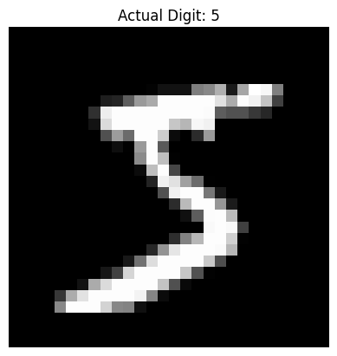
/usr/local/lib/python3.12/dist-packages/keras/src/layers/convolutional/base_conv.py:113: UserWarning: Do not pass an `input_shape`/`input_dim` argument to a layer. When using Sequential models, prefer using an `Input(shape)` object as the first layer in the model instead.
super().__init__(activity_regularizer=activity_regularizer, **kwargs)
Model: "sequential"
┏━━━━━━━━━━━━━━━━━━━━━━━━━━━━━━━━━┳━━━━━━━━━━━━━━━━━━━━━━━━┳━━━━━━━━━━━━━━━┓
┃ Layer (type) ┃ Output Shape ┃ Param # ┃
┡━━━━━━━━━━━━━━━━━━━━━━━━━━━━━━━━━╇━━━━━━━━━━━━━━━━━━━━━━━━╇━━━━━━━━━━━━━━━┩
│ conv2d (Conv2D) │ (None, 26, 26, 32) │ 320 │
├─────────────────────────────────┼────────────────────────┼───────────────┤
│ max_pooling2d (MaxPooling2D) │ (None, 13, 13, 32) │ 0 │
├─────────────────────────────────┼────────────────────────┼───────────────┤
│ flatten (Flatten) │ (None, 5408) │ 0 │
├─────────────────────────────────┼────────────────────────┼───────────────┤
│ dense (Dense) │ (None, 64) │ 346,176 │
├─────────────────────────────────┼────────────────────────┼───────────────┤
│ dense_1 (Dense) │ (None, 10) │ 650 │
└─────────────────────────────────┴────────────────────────┴───────────────┘
Total params: 347,146 (1.32 MB)
Trainable params: 347,146 (1.32 MB)
Non-trainable params: 0 (0.00 B)
Epoch 1/5
1688/1688 ━━━━━━━━━━━━━━━━━━━━ 38s 21ms/step - accuracy: 0.9426 - loss: 0.1922 - val_accuracy: 0.9780 - val_loss: 0.0828
Epoch 2/5
1688/1688 ━━━━━━━━━━━━━━━━━━━━ 31s 18ms/step - accuracy: 0.9806 - loss: 0.0654 - val_accuracy: 0.9842 - val_loss: 0.0601
Epoch 3/5
1688/1688 ━━━━━━━━━━━━━━━━━━━━ 31s 18ms/step - accuracy: 0.9859 - loss: 0.0445 - val_accuracy: 0.9848 - val_loss: 0.0561
Epoch 4/5
1688/1688 ━━━━━━━━━━━━━━━━━━━━ 31s 19ms/step - accuracy: 0.9904 - loss: 0.0311 - val_accuracy: 0.9872 - val_loss: 0.0503
Epoch 5/5
1688/1688 ━━━━━━━━━━━━━━━━━━━━ 30s 18ms/step - accuracy: 0.9927 - loss: 0.0227 - val_accuracy: 0.9883 - val_loss: 0.0485
313/313 ━━━━━━━━━━━━━━━━━━━━ 2s 5ms/step - accuracy: 0.9855 - loss: 0.0489
Test Accuracy: 0.9854999780654907
1/1 ━━━━━━━━━━━━━━━━━━━━ 0s 82ms/step
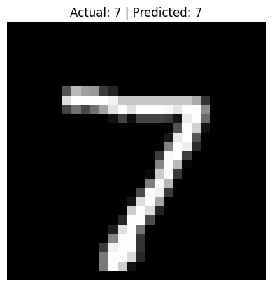

CNN model loaded successfully!
• WhatsApp Image 2026-07-25 at 8.54.36 AM.jpeg(image/jpeg) - 3930 bytes, last modified: 7/25/2026 - 100% done
Saving WhatsApp Image 2026-07-25 at 8.54.36 AM.jpeg to WhatsApp Image 2026-07-25 at 8.54.36 AM.jpeg
Uploaded image: WhatsApp Image 2026-07-25 at 8.54.36 AM.jpeg
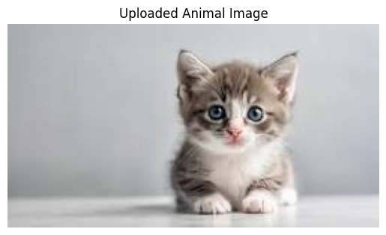
1/1 ━━━━━━━━━━━━━━━━━━━━ 1s 1s/step

Top 3 Predictions:
1. Egyptian cat: 59.36%
2. tabby: 4.04%
3. weasel: 2.73%
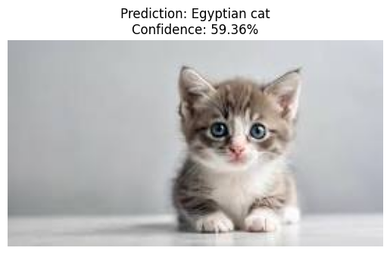

Downloading data from https://storage.googleapis.com/tensorflow/keras-applications/mobilenet_v2/mobilenet_v2_weights_tf_dim_ordering_tf_kernels_1.0_224.h5
14536120/14536120 ━━━━━━━━━━━━━━━━━━━━ 2s 0us/step
CNN model loaded successfully!
• WhatsApp Image 2026-07-25 at 8.54.10 AM.jpeg(image/jpeg) - 7333 bytes, last modified: 7/25/2026 - 100% done
Saving WhatsApp Image 2026-07-25 at 8.54.10 AM.jpeg to WhatsApp Image 2026-07-25 at 8.54.10 AM.jpeg
Uploaded image: WhatsApp Image 2026-07-25 at 8.54.10 AM.jpeg
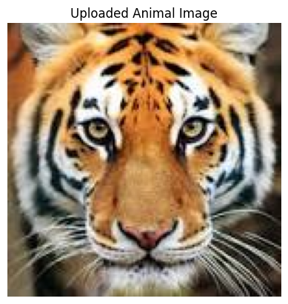
1/1 ━━━━━━━━━━━━━━━━━━━━ 2s 2s/step
Downloading data from https://storage.googleapis.com/download.tensorflow.org/data/imagenet_class_index.json
35363/35363 ━━━━━━━━━━━━━━━━━━━━ 0s 1us/step

Top 3 Predictions:
1. tiger: 72.52%
2. tiger cat: 16.40%
3. jaguar: 3.70%
